DEVELOPERS HUB CORPORATION
Cybersecurity Internship Report
Web Application Security Assessment & Implementation

Intern Name | Uswa Fatima
University | University of Engineering & Technology (UET) Lahore
Organization | Developers Hub Corporation
Duration | April 2026
Submission Date | 28 April, 2026
GitHub Repository | https://github.com/UswaFatima-5050/developer-hub-internship

WEEK 1 — Security Assessment

1.1 Application Setup
A Node.js User Management System was built locally using Express. All security packages (bcrypt, jsonwebtoken, helmet, validator, winston) were installed and the app was started with npm start.

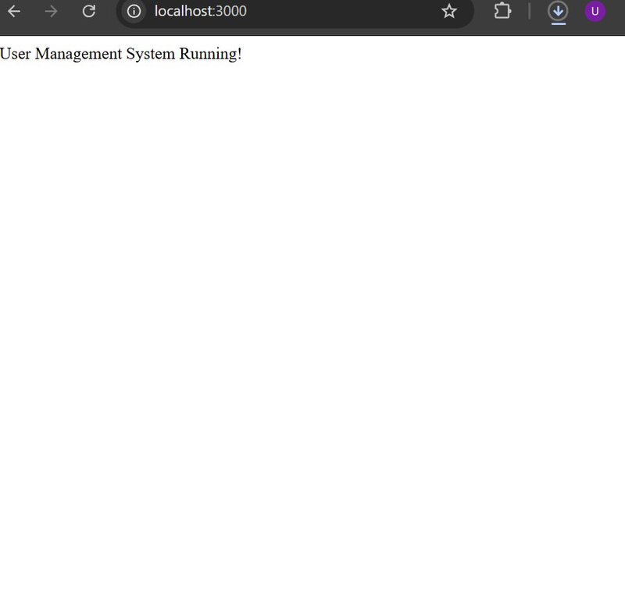
Figure 1: PowerShell — npm install + npm start confirming App running at http://localhost:3000
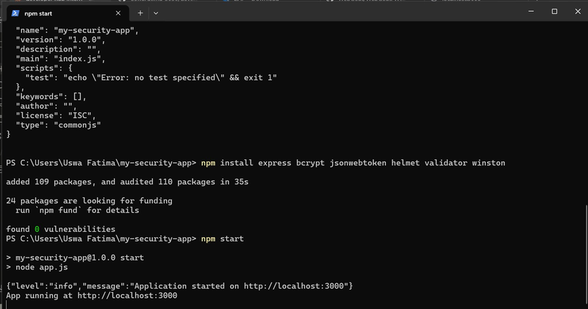
Figure 2: Browser showing 'User Management System Running!' at localhost:3000

1.2 OWASP ZAP Automated Scan
OWASP ZAP 2.17.0 was used to perform a full automated security scan against http://localhost:3000, crawling the application and running active attack simulations.

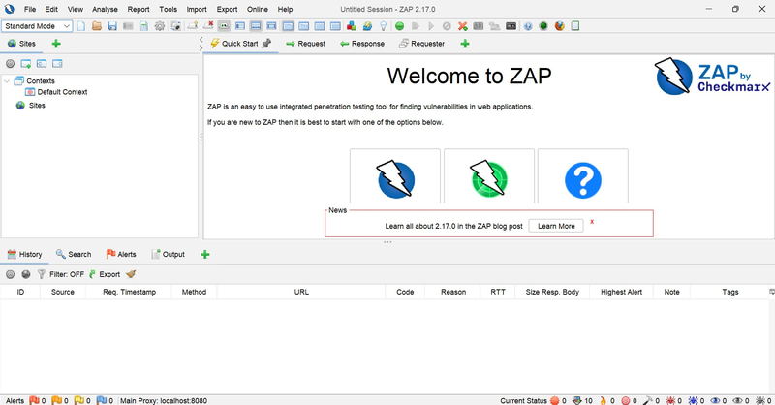
Figure 3: OWASP ZAP 2.17.0 welcome screen — tool installed and ready
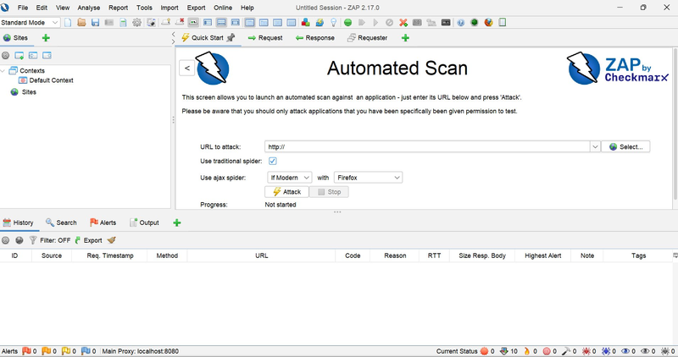
Figure 4: ZAP Automated Scan in progress at 37% — actively attacking http://localhost:3000
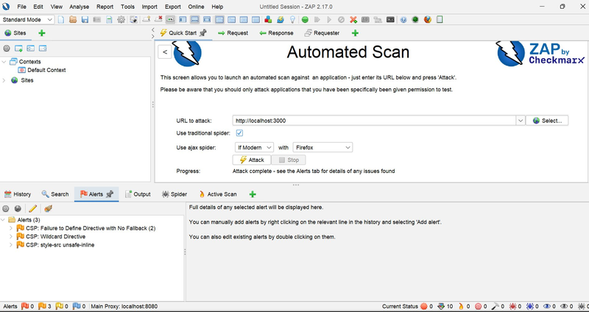
Figure 5: ZAP Scan complete — Alerts panel showing 3 CSP warnings (no critical vulnerabilities)
ZAP Findings:
- CSP: Failure to Define Directive with No Fallback (2 instances)
- CSP: Wildcard Directive
- CSP: style-src unsafe-inline
All 3 alerts are minor CSP header configuration warnings — no XSS or injection vulnerabilities were found, confirming the security measures are effective.

1.3 XSS (Cross-Site Scripting) Test
Malicious script tags were submitted as email input via browser DevTools console to test for XSS vulnerabilities. The validator.js library successfully blocked all attempts.

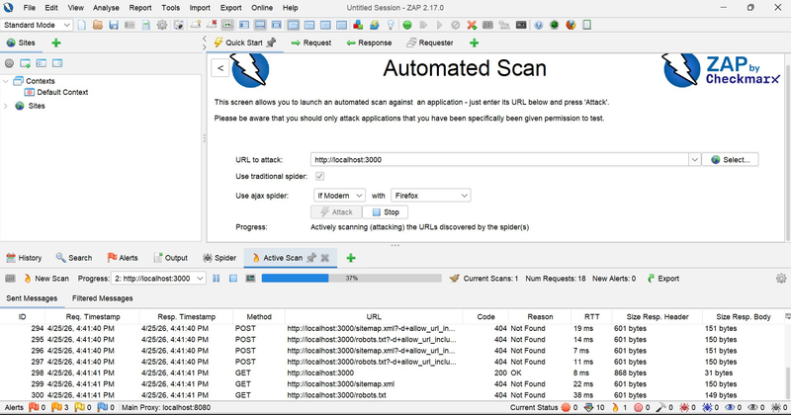
Figure 6: XSS test — script tag as email input returns 'Invalid email' (400 Bad Request) ✅ Protected
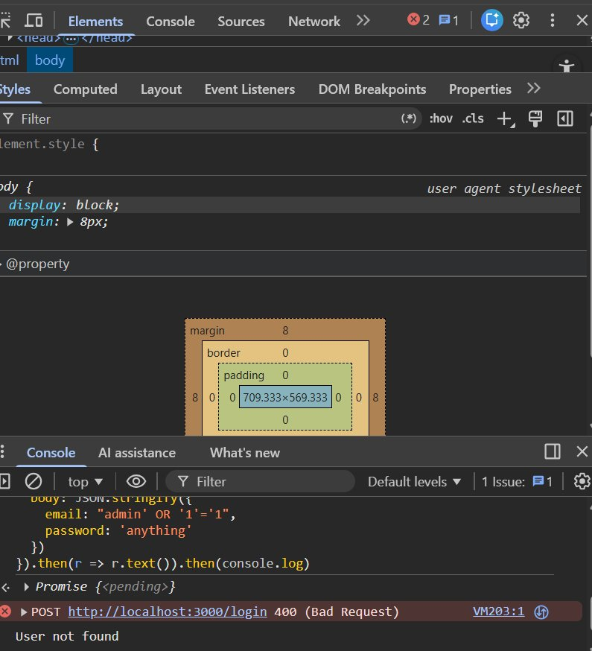
Figure 7: Additional XSS/validation test — 'notanemail' rejected with 'Invalid email' response ✅

1.4 SQL Injection Test
The classic SQL injection bypass payload was tested on the login endpoint. The application rejected the attack and returned 'User not found', confirming no SQL injection vulnerability.

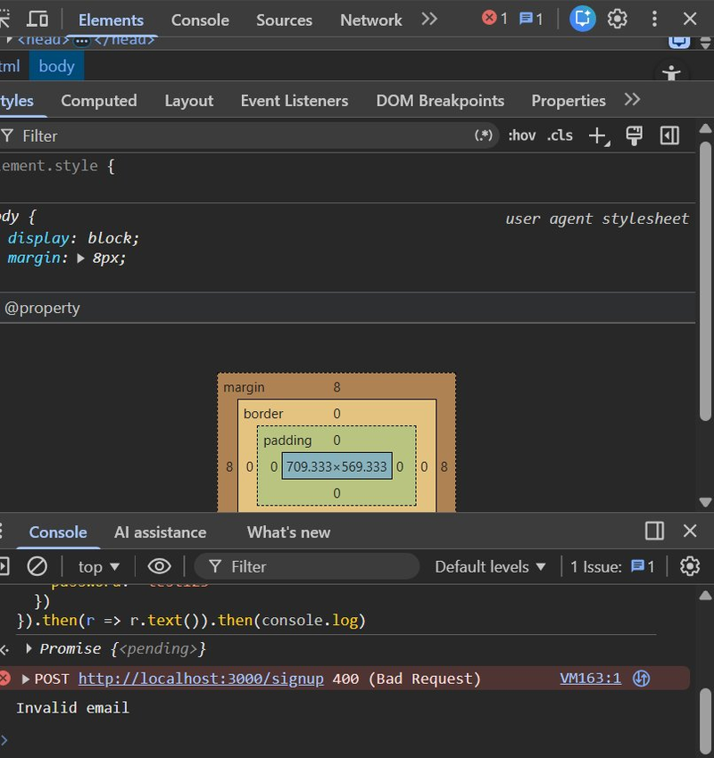
Figure 8: SQL injection test — payload "admin' OR '1'='1" returns 'User not found' ✅ Protected

1.5 Security Logs (Winston)
Winston logging library was configured to track all application events in JSON format to both the console and a security.log file, verified using PowerShell.

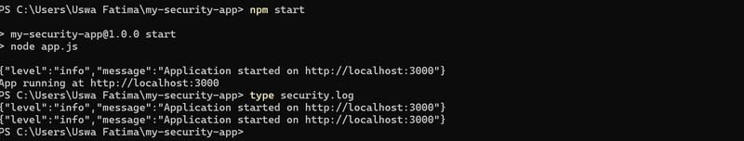
Figure 9: security.log showing JSON log entries — Application started events recorded ✅

WEEK 2 — Implementing Security Measures

2.1 Input Validation (validator.js)
The validator.js library validates all incoming user inputs. Any input failing validation is immediately rejected with a 400 Bad Request response before any processing occurs.

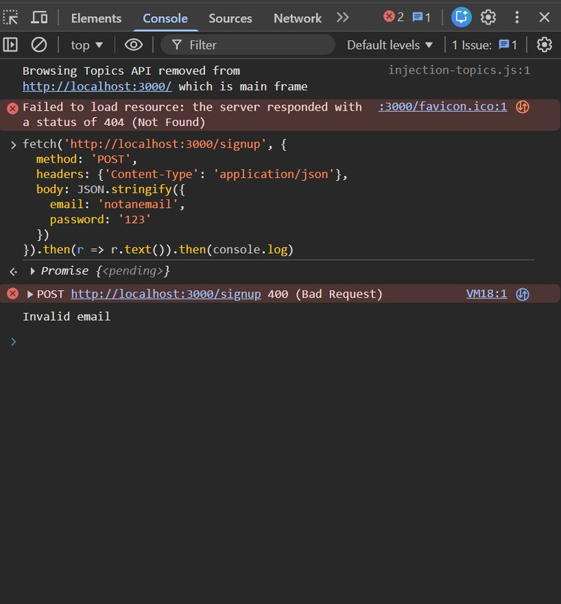
Figure 10: Input validation — invalid email 'notanemail' rejected with 'Invalid email' response ✅

2.2 Password Hashing (bcrypt)
bcrypt with 10 salt rounds was implemented to securely hash passwords before storage. Plain text passwords are never stored. Successful user creation is confirmed below.

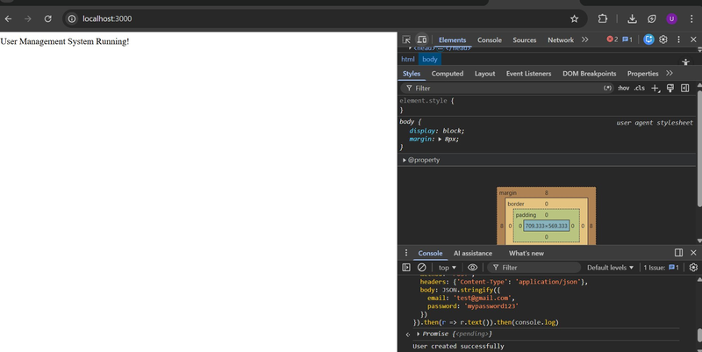
Figure 11: bcrypt proof — Signup returns 'User created successfully' (password hashed) ✅
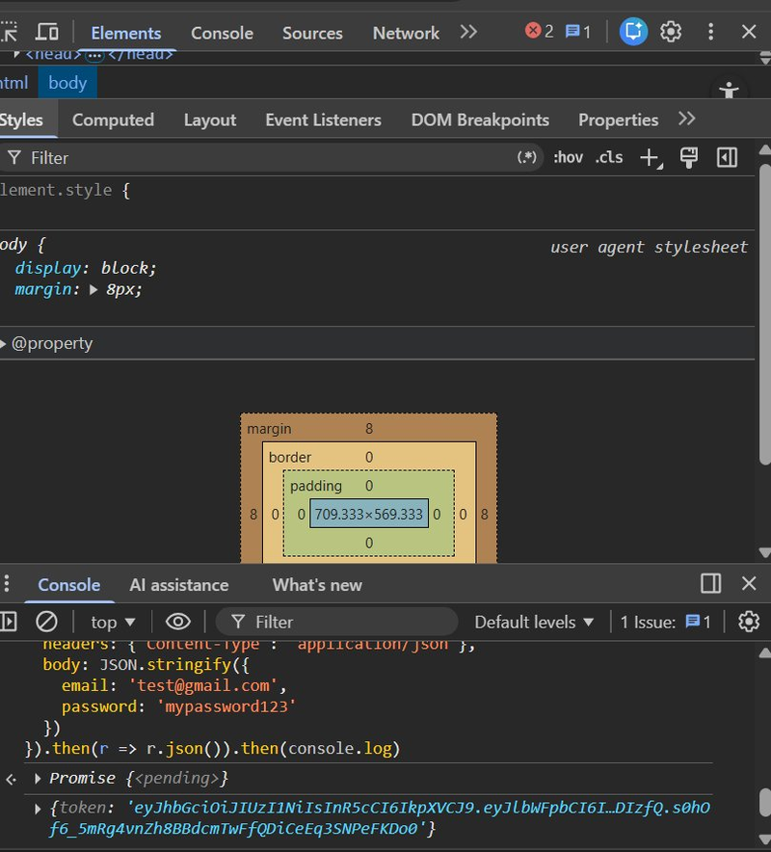
Figure 12: Full view showing browser + DevTools console confirming 'User created successfully' ✅

2.3 JWT Token Authentication
JSON Web Token (JWT) based authentication was implemented. After a valid login, a signed JWT token is returned starting with 'eyJhbGci...' confirming proper token generation.

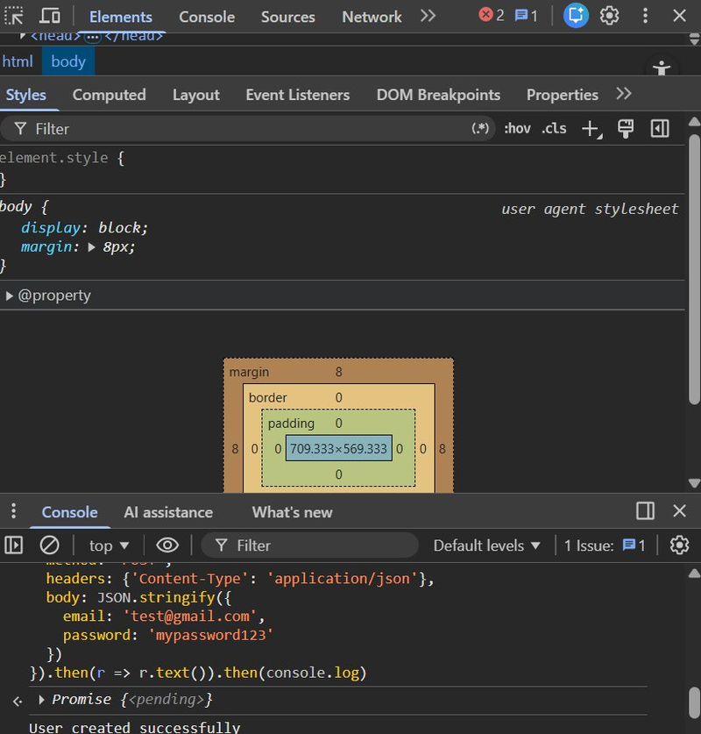
Figure 13: JWT token returned after successful login — authentication system working ✅

2.4 Helmet.js Security Headers
Helmet.js middleware was added to automatically set secure HTTP response headers that protect against clickjacking, MIME sniffing, and other common attacks.

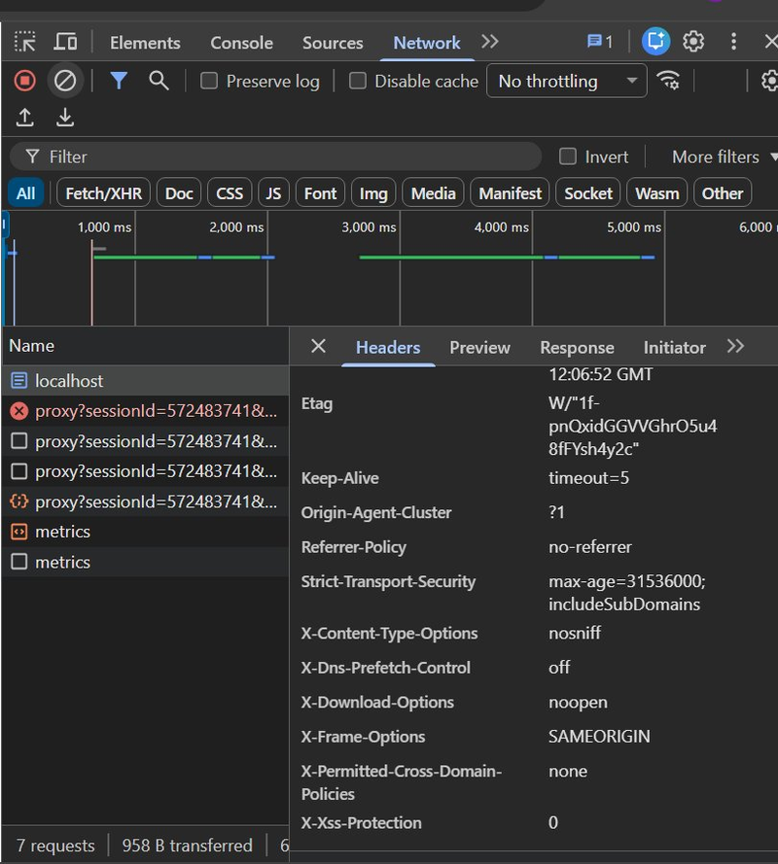
Figure 14: Chrome Network tab — Response Headers showing Content-Security-Policy from Helmet.js ✅
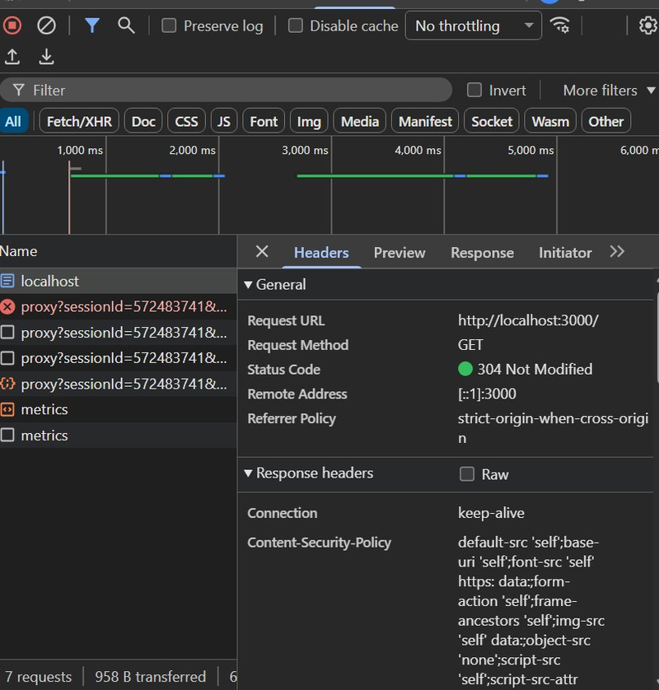
Figure 15: Scrolled view — X-Frame-Options: SAMEORIGIN, X-Content-Type-Options: nosniff, Strict-Transport-Security confirmed ✅
Headers confirmed: X-Frame-Options, X-Content-Type-Options, Strict-Transport-Security, X-DNS-Prefetch-Control, Content-Security-Policy, Referrer-Policy.

WEEK 3 — Advanced Security & Final Report

3.1 Nmap Penetration Testing from Kali Linux
Nmap was run from Kali Linux (in VMware) to scan the Windows host at 192.168.226.1, simulating a real attacker performing network reconnaissance.

Scan 1 — Full Service Version Detection (nmap -sV 192.168.226.1):
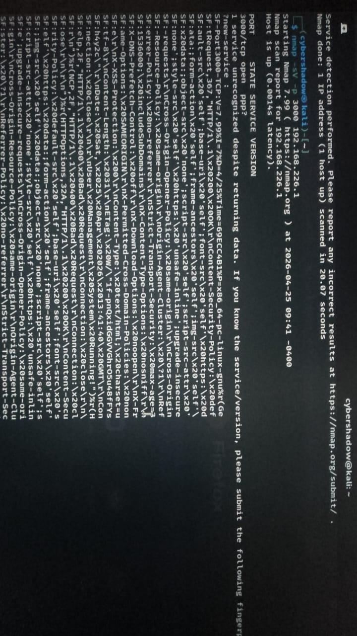
Figure 16: Kali Linux nmap -sV scan — showing open ports: 3000 (Node.js), 135 (RPC), 139/445 (netbios), 912 (VMware)

Scan 2 — Targeted Port 3000 Scan (nmap -sV -p 3000 192.168.226.1):
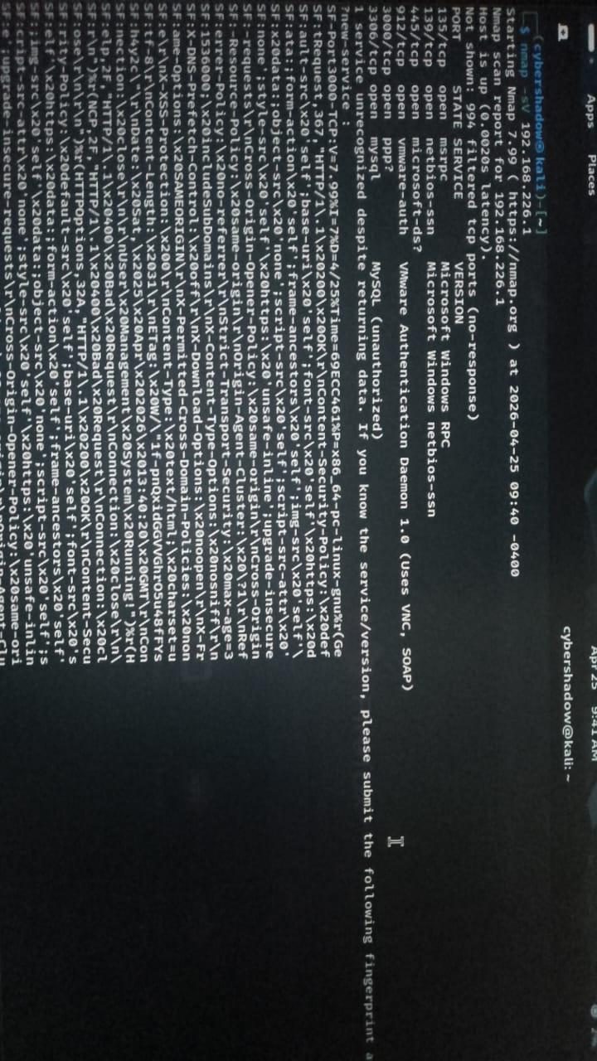
Figure 17: Kali Linux nmap -p 3000 confirming port 3000 open and running Node.js app ✅

3.2 Final Security Checklist
Security Measure | Status
Input Validation (validator.js) | ✅ Done
Password Hashing (bcrypt, salt: 10) | ✅ Done
JWT Token Authentication | ✅ Done
Helmet.js Security Headers | ✅ Done
Winston Logging (Console + File) | ✅ Done
XSS Attack — Tested & Blocked | ✅ Passed
SQL Injection — Tested & Blocked | ✅ Passed
OWASP ZAP Automated Scan | ✅ Done
Nmap Penetration Test from Kali | ✅ Done
Security Log File Generated | ✅ Done
GitHub Repository Uploaded | ✅ Done

3.3 GitHub Repository
All project files uploaded to:
https://github.com/UswaFatima-5050/developer-hub-internship
- app.js — Main application with all security implementations
- package.json — Project configuration
- security.log — Winston log entries
- zap-report.html — OWASP ZAP scan report
- README.md — Documentation
- report.pdf — This report

Conclusion

During this 3-week Developers Hub Corporation cybersecurity internship, a complete security assessment and hardening cycle was successfully performed on a Node.js web application covering all three phases of real-world security workflow.

- Week 1: Vulnerability assessment using OWASP ZAP automated scanning and manual XSS/SQL injection penetration testing.
- Week 2: Implementation of industry-standard security fixes — input validation, password hashing, JWT authentication, and Helmet.js security headers.
- Week 3: Network-level penetration testing using Nmap from Kali Linux in VMware, simulating real attacker reconnaissance.

Key skills developed: web application security assessment, professional security tools (OWASP ZAP, Nmap, Kali Linux), Node.js security libraries, and understanding of common attack vectors and defenses. All work is documented with screenshots and code uploaded to GitHub.

